Project Title
Smart Traffic Speed Violation Detection Platform on Google Cloud
Document Version
- Version: 1.0
- Author: Cloud Solutions Architect
- Cloud Provider: Google Cloud Platform (GCP)
- Architecture Style: Event-Driven, Serverless, IoT-Enabled

1. Executive Summary
This document describes the solution architecture for a cloud-native, IoT-enabled traffic speed violation detection platform built on Google Cloud Platform (GCP). The platform ingests real-time data from roadside cameras and speed sensors, evaluates traffic speed violations, stores raw and processed data for audit and analytics, and notifies vehicle owners with evidence of violations. The solution is designed to be scalable, secure, cost-efficient, and compliant with public-sector data governance requirements.

2. Business Problem Statement
Road traffic authorities require a reliable and scalable system to:
- Monitor vehicle speeds in real time
- Detect speed violations accurately
- Preserve evidence for legal and audit purposes
- Notify offenders promptly
- Support analytics for traffic planning and road safety improvement
Traditional on-premise systems struggle with scalability, high operational costs, and limited real-time capabilities. A cloud-native solution is required to address these limitations.

3. Business Objectives
- Improve road safety through automated speed enforcement
- Enable real-time detection and notification of violations
- Ensure immutable storage of legal evidence
- Support analytics and reporting for traffic authorities
- Minimise infrastructure management through serverless services

4. Non-Functional Requirements
- Scalability: Support thousands of cameras and millions of daily events
- Availability: ≥ 99.9% availability for ingestion and processing
- Security: End-to-end encryption and least-privilege access
- Compliance: Data retention and audit logging
- Latency: Near real-time processing (< seconds)
- Cost Efficiency: Pay-as-you-go, serverless architecture

5. High-Level Architecture Overview
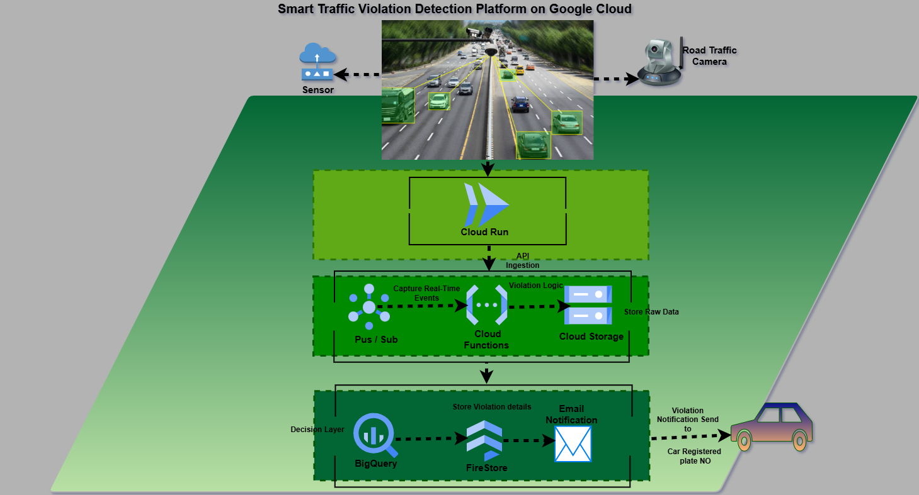

High-level flow:
- Traffic cameras and sensors capture speed, plate number, image, location, and timestamp
- Devices send events securely to a cloud ingestion endpoint
- Events are published to a streaming backbone
- Real-time processing determines violations
- Raw and processed data are stored
- Notifications are sent to vehicle owners

6. Detailed Architecture Components
6.1 Edge & Device Layer
- Roadside traffic cameras and speed sensors
- Devices capture:
  - Vehicle speed
  - Number plate (ANPR)
  - Image snapshot
  - GPS location
  - Timestamp
Devices communicate with the cloud using HTTPS with secure authentication.

6.2 Ingestion Layer
Cloud Run (Ingestion API)
- Acts as a secure entry point for IoT devices
- Handles authentication and payload validation
- Publishes events to Google Cloud Pub/Sub
Justification:
- Fully managed and scalable
- Supports HTTPS endpoints
- Cost-efficient for variable workloads

6.3 Event Streaming & Decoupling
Google Cloud Pub/Sub
- Core event backbone
- Decouples ingestion from processing
- Supports high throughput and event replay

6.4 Real-Time Processing & Violation Logic
Cloud Functions (2nd Gen)
- Triggered by Pub/Sub events
- Performs:
  - Data validation
  - Speed limit lookup by location
  - Violation determination
Violation Rule:
If vehicle_speed > speed_limit → violation = TRUE

6.5 Raw Data Storage (Evidence Layer)
Google Cloud Storage (Raw Zone)
- Stores original event payloads and images
- Versioning and retention policies enabled
- Acts as immutable legal evidence storage

6.6 Data Analytics & Transformation
BigQuery
- Stores processed and structured violation records
- Supports ad-hoc queries and dashboards
Optional:
- Dataflow for advanced streaming transformations

6.7 Query & Action Layer
BigQuery Query / Decision Layer
- Executes SQL queries on processed datasets
- Filters violation records (e.g. speed > limit)
- Produces enforcement-ready datasets
- Acts as the control point before operational persistence

6.8 Operational Data Store
Firestore or Cloud SQL (PostgreSQL)
- Receives only validated and query-approved violation records
- Stores operational records such as:
  - Vehicles
  - Violations
  - Notification status

6.8 Notification Layer
Cloud Functions + External Notification Services
- Sends email or SMS notifications
- Includes:
  - Plate number
  - Speed
  - Location
  - Timestamp
  - Signed URL to image evidence

7. Security Architecture
- IAM with least-privilege roles
- Encryption at rest and in transit
- Cloud KMS for key management
- Secret Manager for credentials
- Cloud Audit Logs for traceability

8. Cost Considerations
- Serverless services reduce idle cost
- Pub/Sub and BigQuery scale with usage
- Cloud Storage lifecycle rules manage long-term storage costs

9. Risks and Mitigations
Risk | Mitigation
High data volume | Pub/Sub and serverless scaling
Data breaches | Encryption, IAM, audit logs
False violations | Validation logic and audit trails

10. Future Enhancements
- Edge processing using Google Distributed Cloud Edge
- AI-based image recognition enhancements
- Real-time dashboards using Looker
- Integration with national vehicle registries

